# Title: Database Design

**Student Name:**

**Student id:**

**1.1 BAND (FUNCTION):**

--CREATING A FUNCTION TO FIND NUMBER OF BAND

CREATE OR REPLACE FUNCTION ADD_BAND_FN (B_MEMBERNO_FN IN INTEGER) RETURN NUMBER

AS

NUMBER_O_MEMBER NUMBER :=0;

BEGIN

SELECT COUNT(*) MEMBER INTO NUMBER_O_MEMBER

FROM BAND WHERE B_MEMBERNO=B_MEMBERNO_FN;

RETURN NUMBER_O_MEMBER;

END ADD_BAND_FN;

--CHECKING FOR DATA

BEGIN

DBMS_OUTPUT.PUT_LINE('NUMBER OF BAND WITH: ' || ADD_BAND_FN (200));

END;

/

**FUNCTION (BAND):**

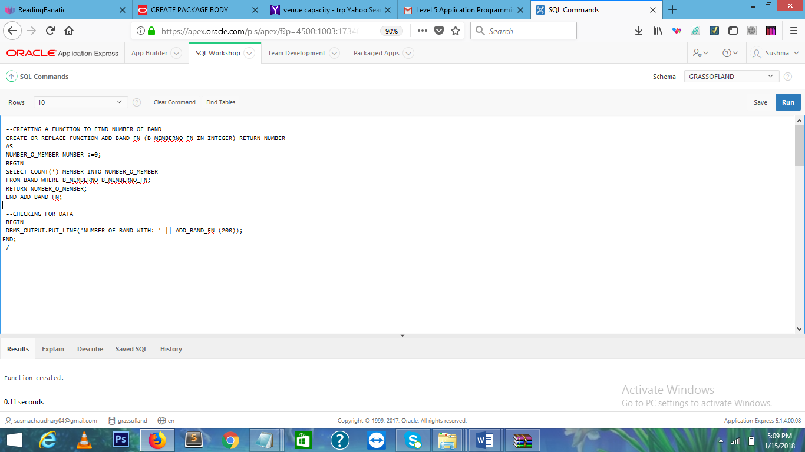

IN THE ABOVE SCREENSHOT,FUNTION IS CREATED WHICH IS OF BAND.

**CHECKING DATA:**

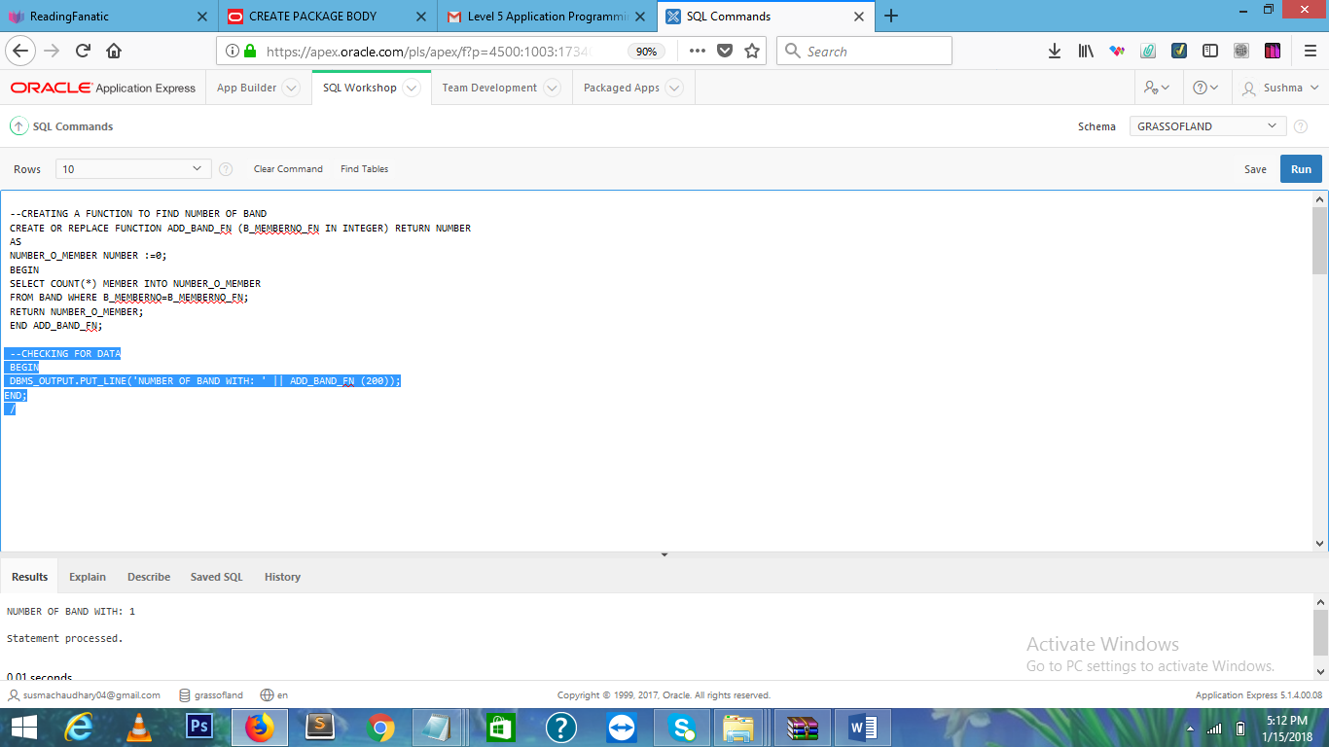

IN ABOVE SCREENSHOT,CODE FOR CHECKING DATA IS IMPLIED.THUS DATA IS SUCCESSFULLY CHECKED AS WE CAN SEE NUMBER OF BAND WITH:1.OUTPUT AND STATEMENT PROCCESSED .

**1.2 PROCEDURE (BAND):**

CREATE OR REPLACE PROCEDURE ADD_BAND(BAND_ID_I IN INTEGER,B_NAME_I IN VARCHAR2, B_MEMBERNO_I IN INTEGER,GENRE_I IN VARCHAR2,STAGE_NO_I IN INTEGER)

AS

BEGIN

IF BAND_ID_I IS NULL

THEN

RAISE VALUE_ERROR;

END IF;

INSERT INTO BAND(BAND_ID,B_NAME,B_MEMBERNO,GENRE,STAGE_NO) VALUES (BAND_ID_I,B_NAME_I,B_MEMBERNO_I,GENRE_I,STAGE_NO_I);

END ADD_BAND;

**PROCEDURE(BAND):**

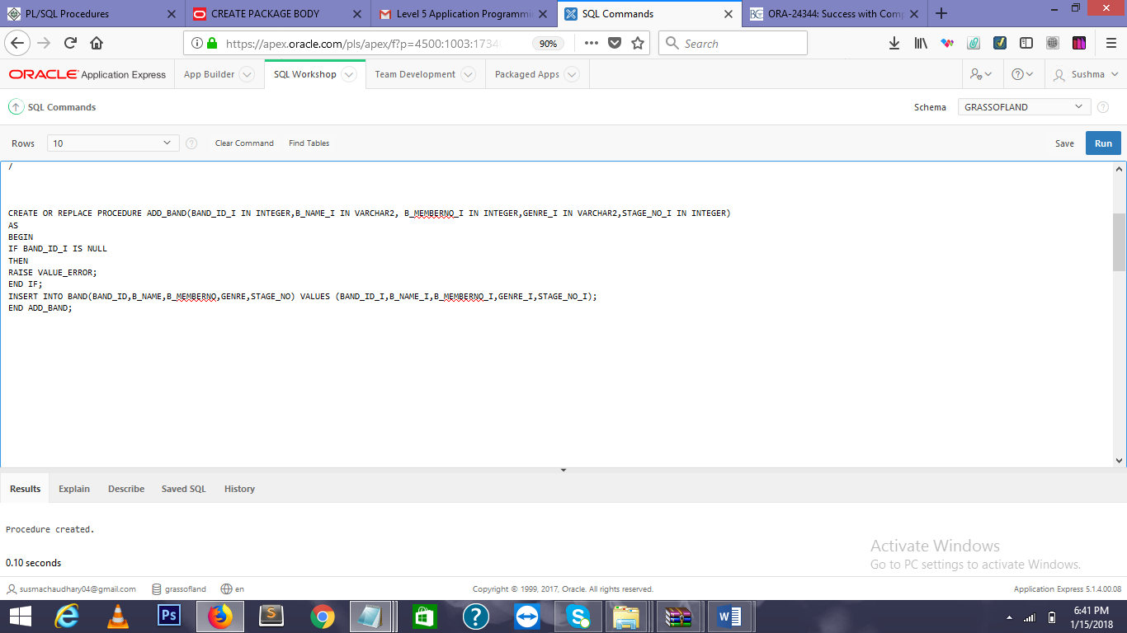

THE PROCEDURE IS CREATED IN THIS SCREENSHOT.

**1.3 PACKAGE(BAND):**

--CREATING A PACKAGE TO INSERT DATA TO BAND

CREATE OR REPLACE PACKAGE PACK_ADD

AS

FUNCTION ADD_BAND_FN RETURN NUMBER;

PROCEDURE ADD_BAND;

END PACK_ADD;

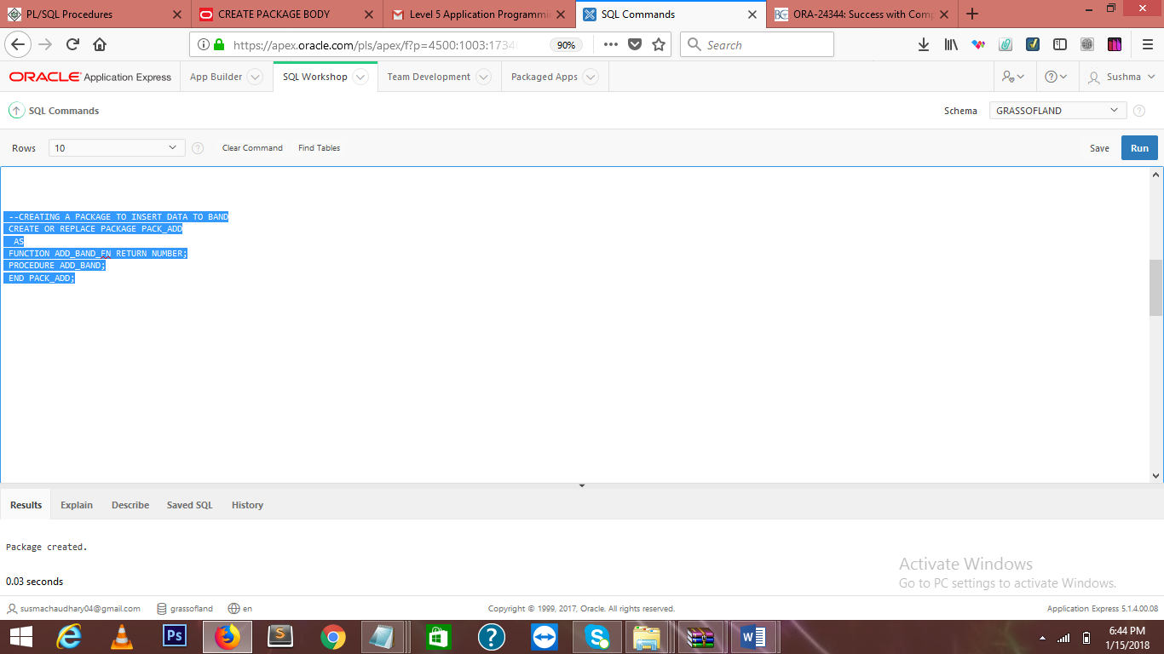

ABOVE SCREENSHOT IS OF PACKAGE CREATED.AFTER CREATING FUNCTION AND PROCEDURE ,PACKAGE IS CREATED AS INODER TO CREATE PACKAGE, FUNCTION AND PROCEDURE IS REQUIRED.

**1.4 TRIGGER:(VENUE):**

**1.**

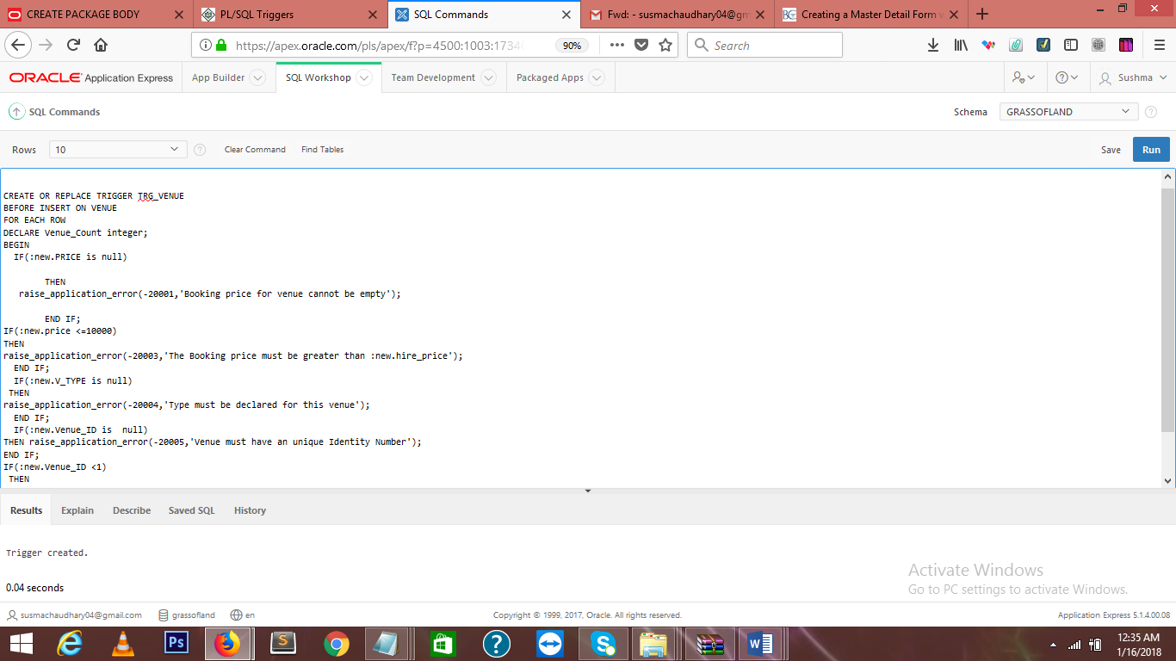

IN THIS ABOVE SCREENSHOT,WE CAN SEE A TRIGGER IS CREATED WHICH IS OF venue.

CREATE OR REPLACE TRIGGER TRG_VENUE

BEFORE INSERT ON VENUE

FOR EACH ROW

DECLARE Venue_Count integer;

BEGIN

IF(:new.PRICE is null)

THEN

raise_application_error(-20001,'Booking price for venue cannot be empty');

END IF;

IF(:new.price <=10000)

THEN

raise_application_error(-20003,'The Booking price must be greater than :new.hire_price');

END IF;

IF(:new.V_TYPE is null)

THEN

raise_application_error(-20004,'Type must be declared for this venue');

END IF;

IF(:new.Venue_ID is null)

THEN raise_application_error(-20005,'Venue must have an unique Identity Number');

END IF;

IF(:new.Venue_ID <10)

THEN

raise_application_error(-20006,'The Identity Number for Venue cannot be less than 10');

END IF;

END;

TESTING:

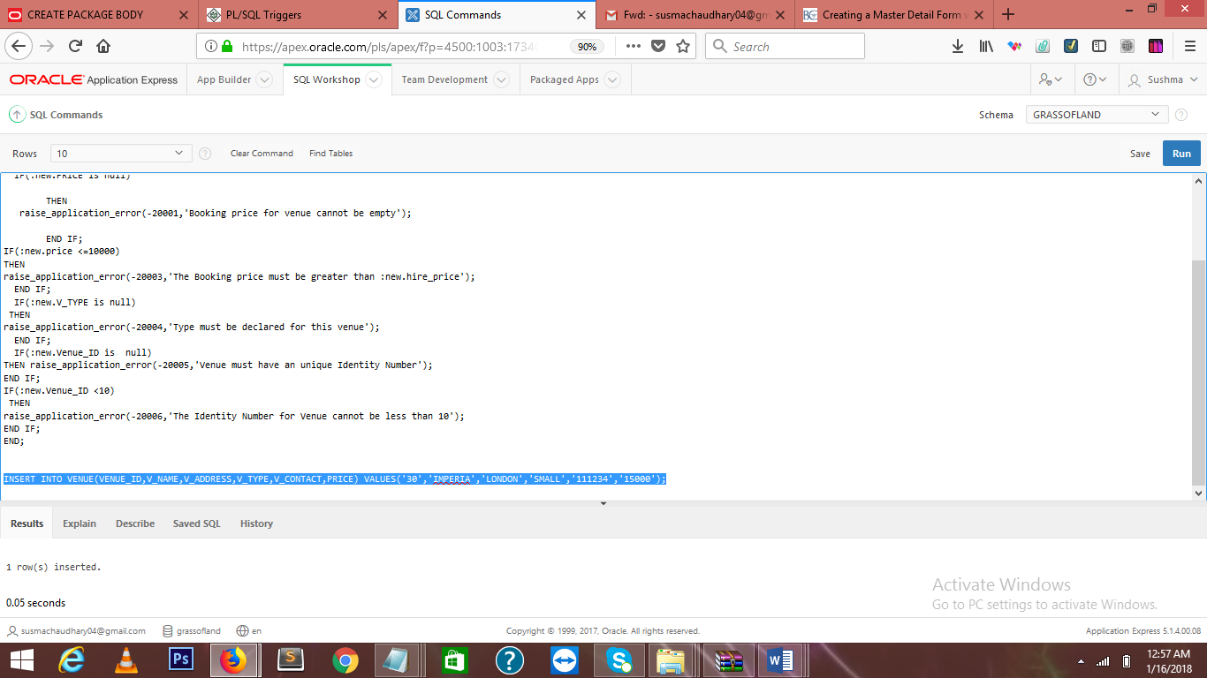

IN ABOVE SCREENSHOT TRIGGER IS TESTED BY

INSERT INTO VENUE(VENUE_ID,V_NAME,V_ADDRESS,V_TYPE,V_CONTACT,PRICE) VALUES('9','IMPERIA','LONDON','SMALL','111234','15000');

THUS 1 ROW IS INSERTED.

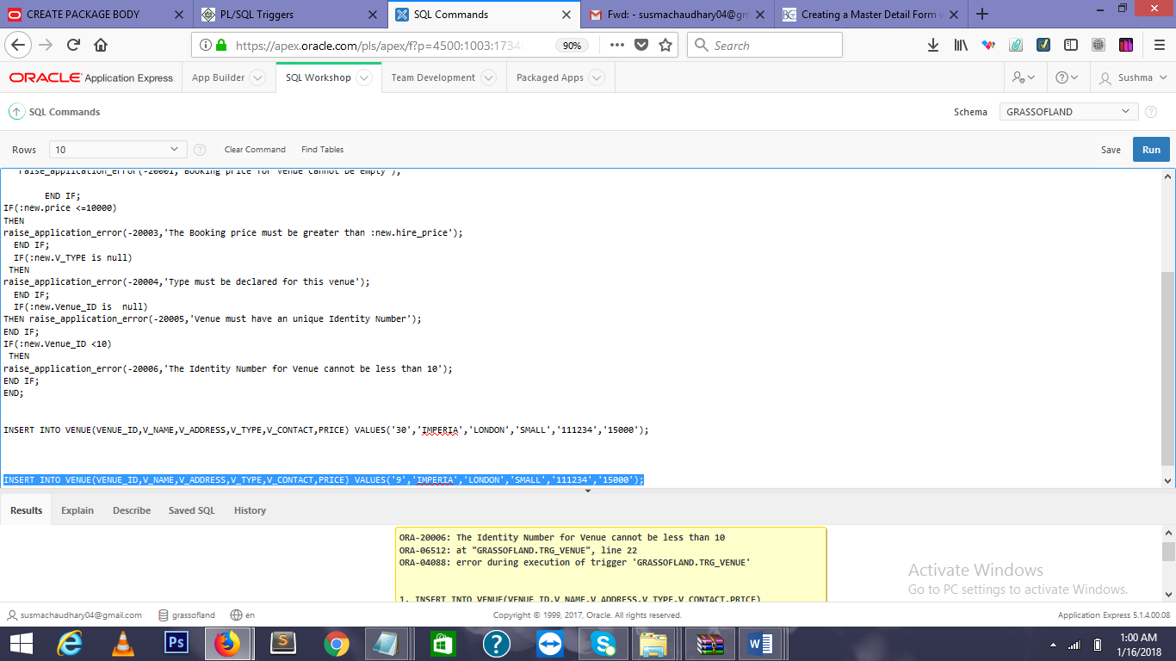

INSERT INTO VENUE(VENUE_ID,V_NAME,V_ADDRESS,V_TYPE,V_CONTACT,PRICE) VALUES('9','IMPERIA','LONDON','SMALL','111234','15000');

IN THIS SCREENSHOT ,ERROR IS OCCURRED,AS IT DID NOT MEET THE REQUIREMENT OF THE ABOVE STATEMENT.I.E “THE IDENTITY NUMBER FOR VENUE CANNOT BE LESS THAN 10.”

**1.5.FESTIVAL**

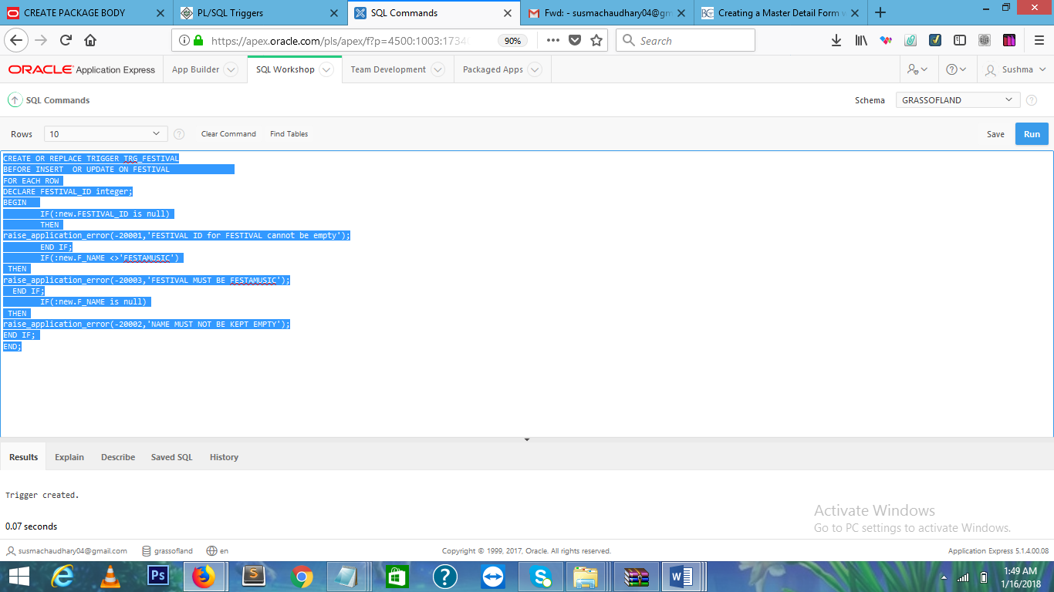

IN THIS ABOVE TRIGGER IS CREATED WHICH OF FESTIVAL.

CREATE OR REPLACE TRIGGER TRG_FESTIVAL

BEFORE INSERT OR UPDATE ON FESTIVAL

FOR EACH ROW

DECLARE FESTIVAL_ID integer;

BEGIN

IF(:new.FESTIVAL_ID is null)

THEN

raise_application_error(-20001,'FESTIVAL ID for FESTIVAL cannot be empty');

END IF;

IF(:new.F_NAME <>'FESTAMUSIC')

THEN

raise_application_error(-20003,'FESTIVAL MUST BE FESTAMUSIC');

END IF;

IF(:new.F_NAME is null)

THEN

raise_application_error(-20002,'NAME MUST NOT BE KEPT EMPTY');

END IF;

END;

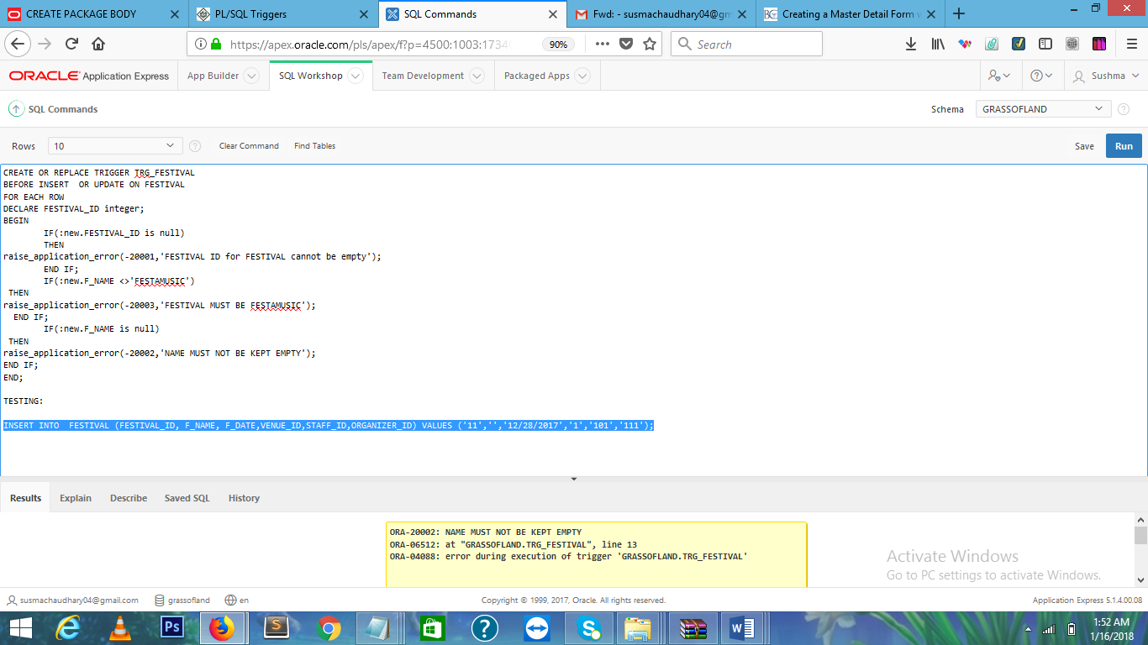

IN THIS SCREENSHOT,ERROR MESSAGE IS DISPLAYED ,AS IT DID NOT MEET THE REQUIREMENT OF THE ABOVE STATEMENT.I.E “NAME MUST NOT BE KEPT EMPTY.”

INSERT INTO FESTIVAL (FESTIVAL_ID, F_NAME, F_DATE,VENUE_ID,STAFF_ID,ORGANIZER_ID) VALUES ('11','','12/28/2017','1','101','111');

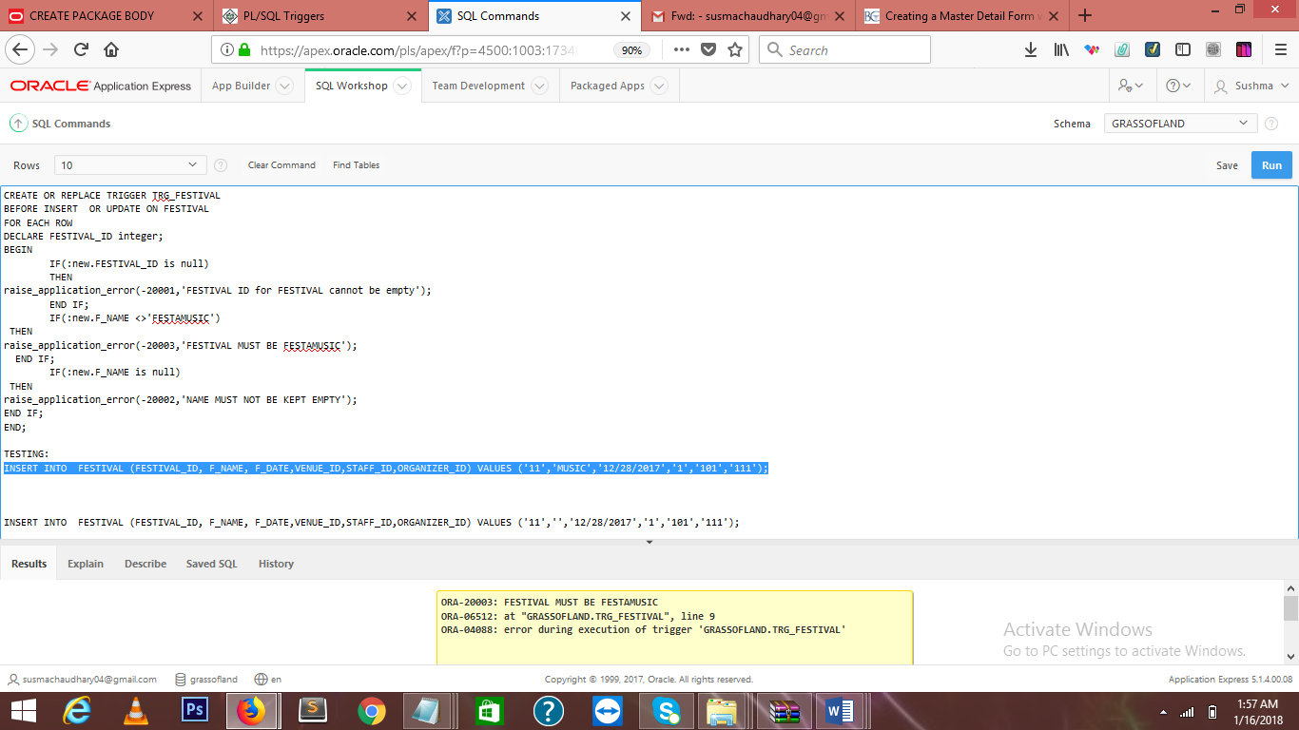 INSERT INTO FESTIVAL (FESTIVAL_ID, F_NAME, F_DATE,VENUE_ID,STAFF_ID,ORGANIZER_ID) VALUES ('11','MUSIC','12/28/2017','1','101','111');

IN THIS SCREENSHOT,ERROR IS OCCURRED,AS IT DID NOT MEET THE REQUIREMENT OF THE ABOVE STATEMENT.I.E “FESTIVAL MUST BE FESTAMUSIC.”

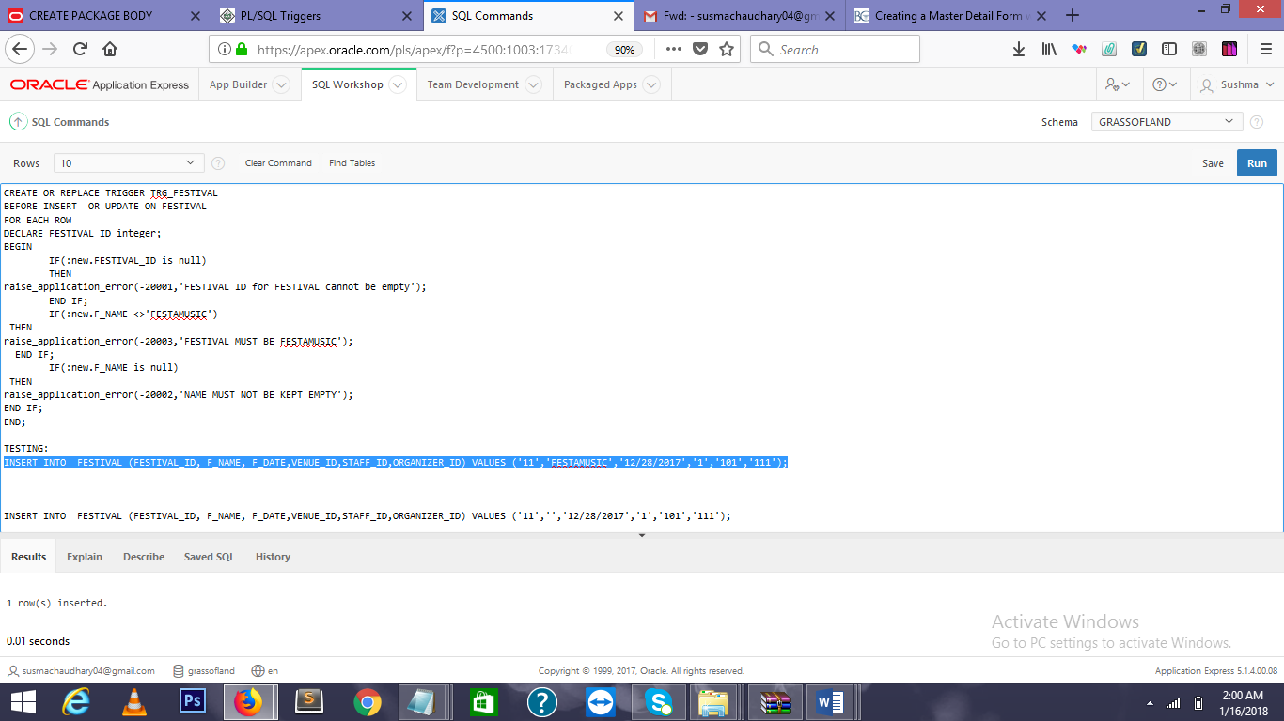

INSERT INTO FESTIVAL (FESTIVAL_ID, F_NAME, F_DATE,VENUE_ID,STAFF_ID,ORGANIZER_ID) VALUES ('11','FESTAMUSIC','12/28/2017','1','101','111');

**1.6.BAND:**

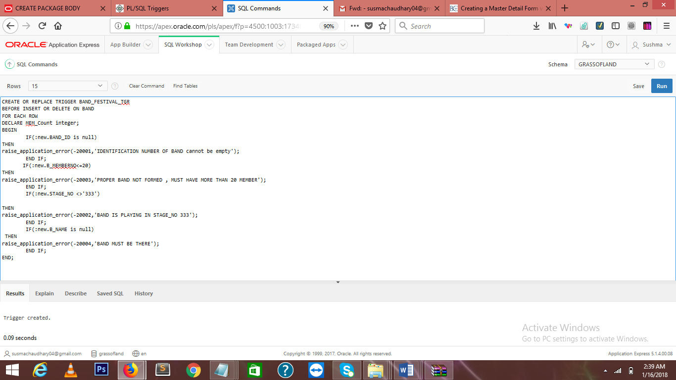

HERE, TRIGGER IS CREATED WHICH IS OF BAND.

CREATE OR REPLACE TRIGGER BAND_FESTIVAL_TGR

BEFORE INSERT OR DELETE ON BAND

FOR EACH ROW

DECLARE MEM_Count integer;

BEGIN

IF(:new.BAND_ID is null)

THEN

raise_application_error(-20001,'IDENTIFICATION NUMBER OF BAND cannot be empty');

END IF;

IF(:new.B_MEMBERNO<=20)

THEN

raise_application_error(-20003,'PROPER BAND NOT FORMED , MUST HAVE MORE THAN 20 MEMBER');

END IF;

IF(:new.STAGE_NO <>'333')

THEN

raise_application_error(-20002,'BAND IS PLAYING IN STAGE_NO 333');

END IF;

IF(:new.B_NAME is null)

THEN

raise_application_error(-20004,'BAND MUST BE THERE');

END IF;

END;

**2. REPORTS:**

**2.1CLASSIC REPORT OF STAFF:**

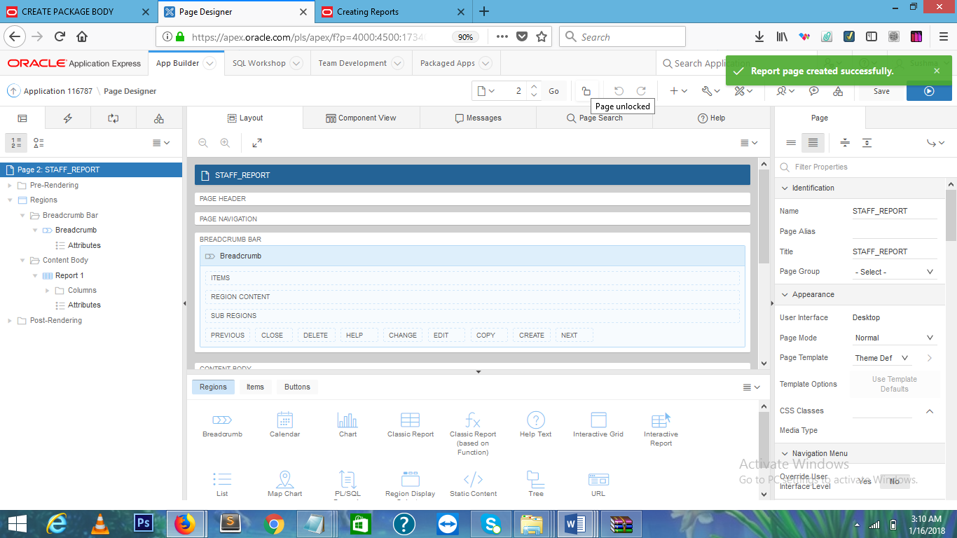

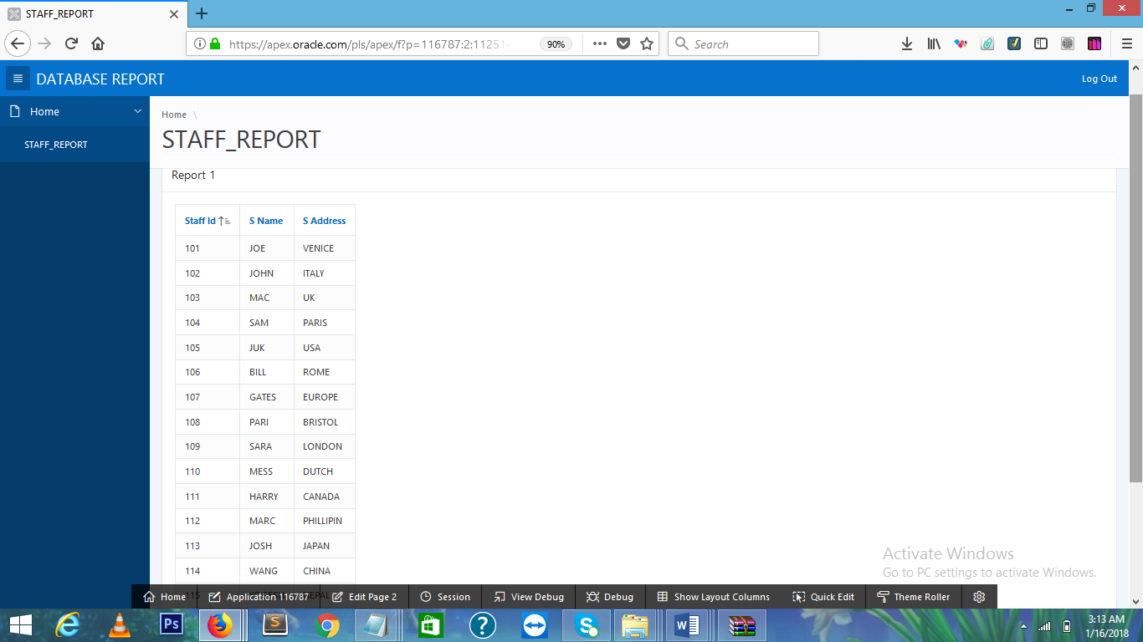

**ABOVE SCREENSHOT IS CLASSICAL REPORT OF STAFF WHICH CONTAIN DATA LIKE SATFF_ID,S_NAME ANDS_ADDRESS.**

**2.2 STAFF VENUE REPORT:**

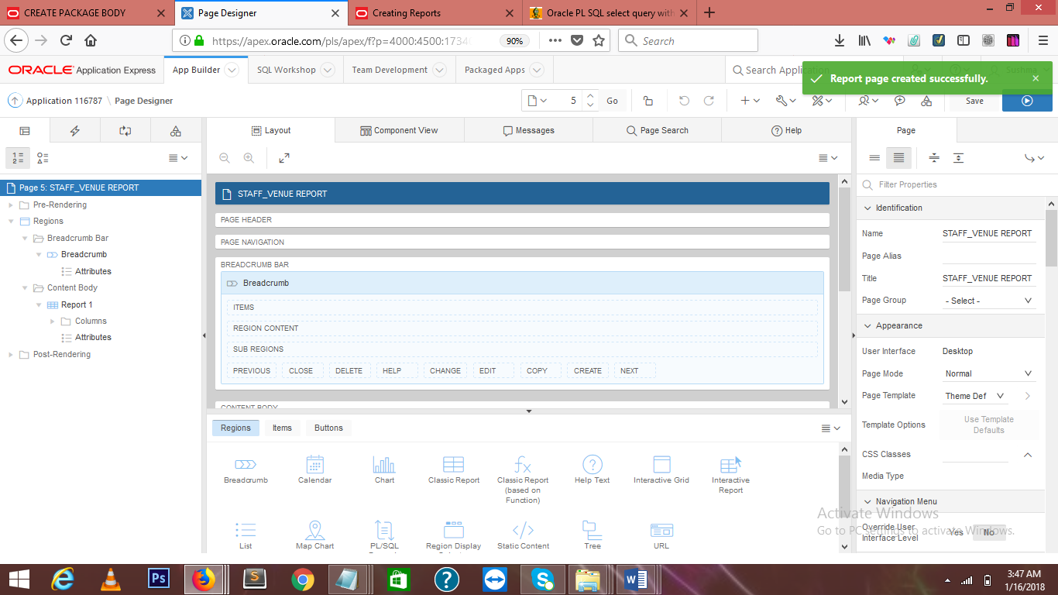

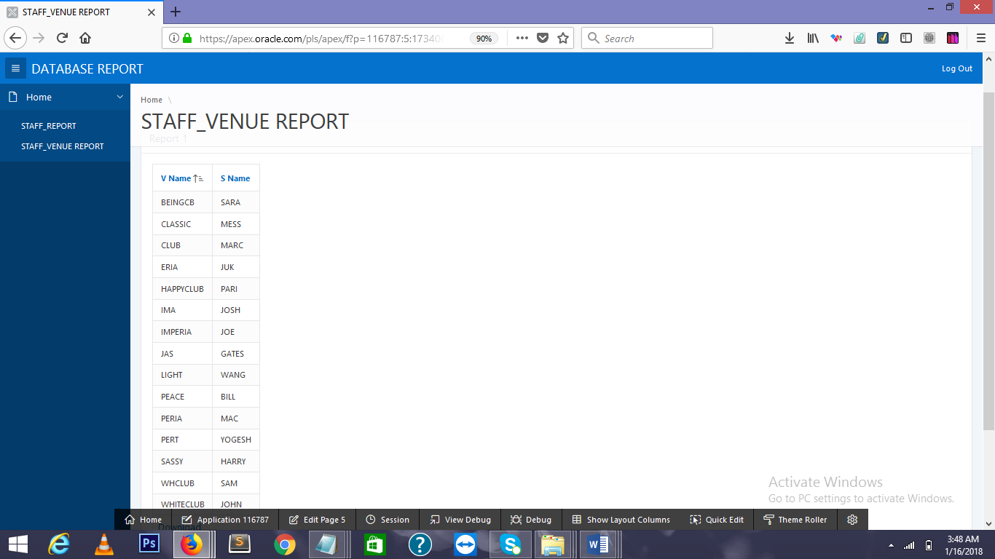

**ABOVE SCREENSHOT IS CLASSICAL REPORT OF SAFF AND VENUE.IN THIS TWO TABLE I.E SATFF AND VENUE IS JOINED.**

**2.3 STAFF_FEST REPORT:**

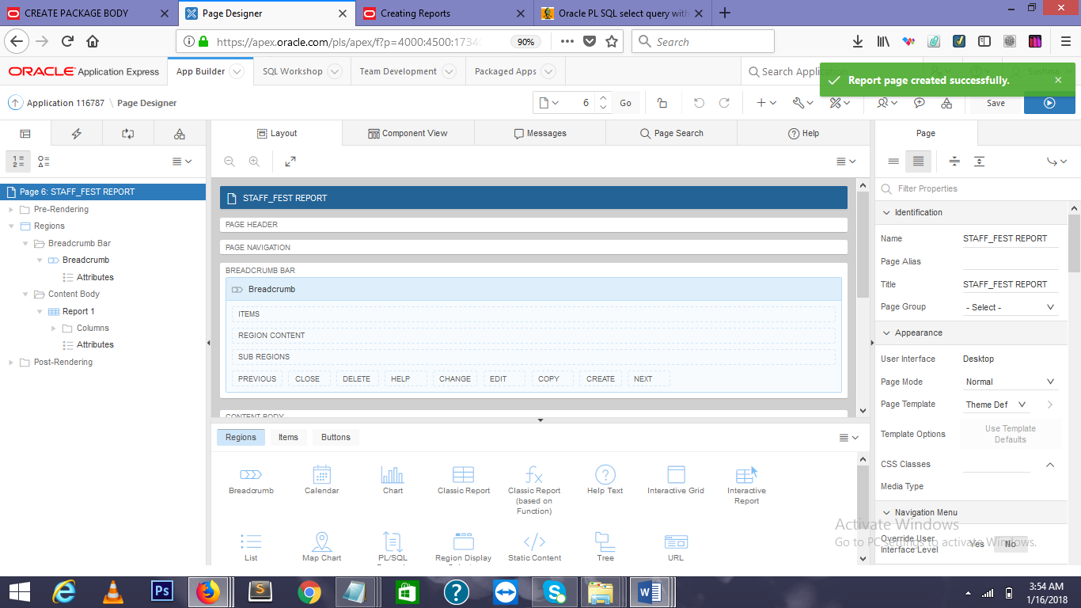

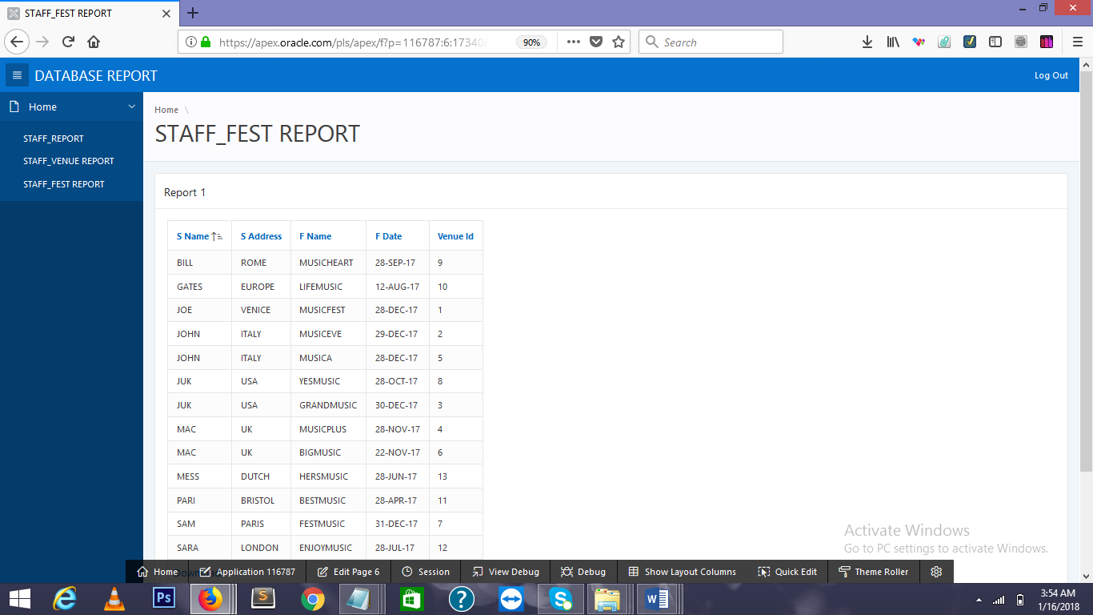

**ABOVE SCREENSHOT IS CLASSICAL REPORT OF SAFF AND FESTIVAL .IN THIS TWO TABLE I.E SATFF AND FESTIVAL IS JOINED WHICH CONTAIN S_NAME,S_ADDRESS,F_NAME,VENUE_ID.**

**2.4 MASTER DETAIL FORM OF VENUE:**

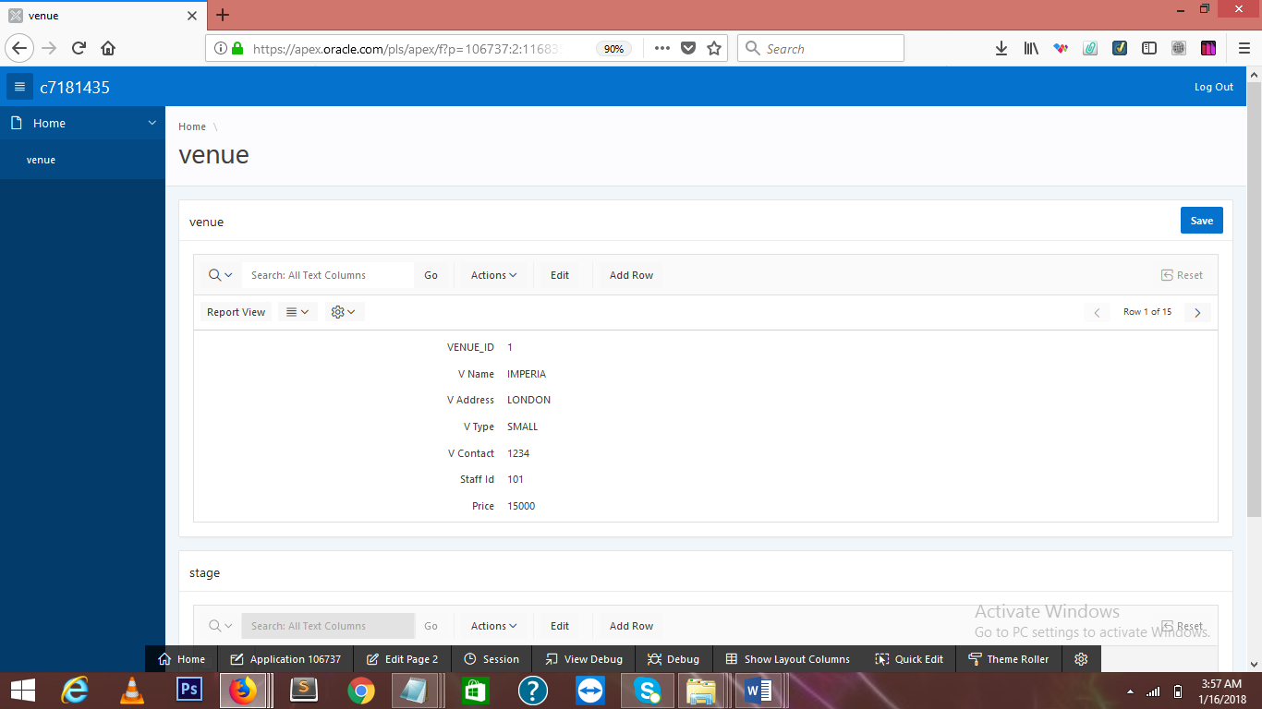

**ABOVE SCREENSHOT IS THE MASTER DETAIL FORM OF VENUE.**

**DML,DDL,VIEW ,CODES:**

DROP TABLE STAFF CASCADE CONSTRAINTS ;

DROP TABLE FESTIVAL CASCADE CONSTRAINTS ;

DROP TABLE VENUE CASCADE CONSTRAINTS;

DROP TABLE BAND CASCADE CONSTRAINTS ;

DROP TABLE STAGE CASCADE CONSTRAINTS;

DROP TABLE ORGANIZER CASCADE CONSTRAINTS;

DROP TABLE EQUIPMENT CASCADE CONSTRAINTS;

DROP TABLE AGENT CASCADE CONSTRAINTS;

CREATE TABLE STAFF(

STAFF_ID INTEGER PRIMARY KEY,

S_NAME VARCHAR2(50),

S_ADDRESS VARCHAR2(50)

);

CREATE TABLE ORGANIZER(

ORGANIZER_ID INTEGER PRIMARY KEY,

O_NAME VARCHAR2(50));

CREATE TABLE VENUE(

VENUE_ID INTEGER PRIMARY KEY,

V_NAME VARCHAR2(50),

V_ADDRESS VARCHAR2(50),

V_TYPE VARCHAR2(25),

V_CONTACT INTEGER,

STAFF_ID INTEGER REFERENCES STAFF(STAFF_ID),

PRICE INTEGER

);

CREATE TABLE FESTIVAL(

FESTIVAL_ID INTEGER PRIMARY KEY,

F_NAME VARCHAR2(50),

F_DATE DATE,

VENUE_ID INTEGER REFERENCES VENUE(VENUE_ID),

STAFF_ID INTEGER REFERENCES STAFF(STAFF_ID),

ORGANIZER_ID INTEGER REFERENCES ORGANIZER(ORGANIZER_ID));

CREATE TABLE STAGE(

STAGE_NO INTEGER PRIMARY KEY,

VENUE_ID INTEGER REFERENCES VENUE(VENUE_ID),

STAGE_SIZE INTEGER);

CREATE TABLE BAND(

BAND_ID INTEGER PRIMARY KEY,

B_NAME VARCHAR2(25),

B_MEMBERNO INTEGER,

GENRE VARCHAR2(25),

STAGE_NO INTEGER REFERENCES STAGE(STAGE_NO)

);

CREATE TABLE EQUIPMENT(

EQUIPMENT_ID INTEGER PRIMARY KEY,

E_NAME VARCHAR2(50),

NO_OF_EQUIPMENT INTEGER

);

CREATE TABLE AGENT(

AGENT_ID INTEGER PRIMARY KEY,

A_NAME VARCHAR2(50),

A_ADDRESS VARCHAR2(25),

A_CONTACTNO INTEGER

);

INSERT INTO STAFF (STAFF_ID, S_NAME, S_ADDRESS) VALUES (101, 'JOE', 'VENICE');

INSERT INTO STAFF (STAFF_ID, S_NAME, S_ADDRESS) VALUES (102, 'JOHN', 'ITALY');

INSERT INTO STAFF (STAFF_ID, S_NAME, S_ADDRESS) VALUES (103, 'MAC', 'UK');

INSERT INTO STAFF (STAFF_ID, S_NAME, S_ADDRESS) VALUES (104, 'SAM', 'PARIS');

INSERT INTO STAFF (STAFF_ID, S_NAME, S_ADDRESS) VALUES (105, 'JUK', 'USA');

INSERT INTO STAFF (STAFF_ID, S_NAME, S_ADDRESS) VALUES (106, 'BILL', 'ROME');

INSERT INTO STAFF (STAFF_ID, S_NAME, S_ADDRESS) VALUES (107, 'GATES', 'EUROPE');

INSERT INTO STAFF (STAFF_ID, S_NAME, S_ADDRESS) VALUES (108, 'PARI', 'BRISTOL');

INSERT INTO STAFF (STAFF_ID, S_NAME, S_ADDRESS) VALUES (109, 'SARA', 'LONDON');

INSERT INTO STAFF (STAFF_ID, S_NAME, S_ADDRESS) VALUES (110, 'MESS', 'DUTCH');

INSERT INTO STAFF (STAFF_ID, S_NAME, S_ADDRESS) VALUES (111, 'HARRY', 'CANADA');

INSERT INTO STAFF (STAFF_ID, S_NAME, S_ADDRESS) VALUES (112, 'MARC', 'PHILLIPIN');

INSERT INTO STAFF (STAFF_ID, S_NAME, S_ADDRESS) VALUES (113, 'JOSH', 'JAPAN');

INSERT INTO STAFF (STAFF_ID, S_NAME, S_ADDRESS) VALUES (114, 'WANG', 'CHINA');

INSERT INTO STAFF (STAFF_ID, S_NAME, S_ADDRESS) VALUES (115, 'YOGESH', 'NEPAL');

INSERT INTO ORGANIZER (ORGANIZER_ID, O_NAME) VALUES (111,'BRENT');

INSERT INTO ORGANIZER(ORGANIZER_ID, O_NAME) VALUES (112, 'MASON');

INSERT INTO ORGANIZER (ORGANIZER_ID, O_NAME) VALUES (113,'BROWN');

INSERT INTO ORGANIZER(ORGANIZER_ID, O_NAME) VALUES (114, 'MAS');

INSERT INTO ORGANIZER (ORGANIZER_ID, O_NAME) VALUES (115,'JAE');

INSERT INTO ORGANIZER(ORGANIZER_ID, O_NAME) VALUES (116, 'ASON');

INSERT INTO ORGANIZER (ORGANIZER_ID, O_NAME) VALUES (117,'RENT');

INSERT INTO ORGANIZER(ORGANIZER_ID, O_NAME) VALUES (118, 'BUKE');

INSERT INTO ORGANIZER (ORGANIZER_ID, O_NAME) VALUES (119,'HASON');

INSERT INTO ORGANIZER(ORGANIZER_ID, O_NAME) VALUES (120, 'DYLON');

INSERT INTO ORGANIZER (ORGANIZER_ID, O_NAME) VALUES (121,'DANI');

INSERT INTO ORGANIZER(ORGANIZER_ID, O_NAME) VALUES (122, 'PAM');

INSERT INTO ORGANIZER (ORGANIZER_ID, O_NAME) VALUES (123,'TOM');

INSERT INTO ORGANIZER(ORGANIZER_ID, O_NAME) VALUES (124, 'MASO');

INSERT INTO ORGANIZER (ORGANIZER_ID, O_NAME) VALUES (125,'BAN');

INSERT INTO FESTIVAL (FESTIVAL_ID, F_NAME, F_DATE,VENUE_ID,STAFF_ID,ORGANIZER_ID) VALUES (11,'MUSICFEST','12/28/2017','1','101','111');

INSERT INTO FESTIVAL (FESTIVAL_ID, F_NAME, F_DATE,VENUE_ID,STAFF_ID,ORGANIZER_ID) VALUES ('12','MUSICEVE','12/29/2017','2','102','112');

INSERT INTO FESTIVAL (FESTIVAL_ID, F_NAME, F_DATE,VENUE_ID,STAFF_ID,ORGANIZER_ID) VALUES ('13','GRANDMUSIC','12/30/2017','3','105','113');

INSERT INTO FESTIVAL (FESTIVAL_ID, F_NAME, F_DATE,VENUE_ID,STAFF_ID,ORGANIZER_ID) VALUES ('14','MUSICPLUS','11/28/2017','4','103','114');

INSERT INTO FESTIVAL (FESTIVAL_ID, F_NAME, F_DATE,VENUE_ID,STAFF_ID,ORGANIZER_ID) VALUES ('15','MUSICA','12/28/2017','5','102','115');

INSERT INTO FESTIVAL (FESTIVAL_ID, F_NAME, F_DATE,VENUE_ID,STAFF_ID,ORGANIZER_ID) VALUES ('16','BIGMUSIC','11/22/2017','6','103','116');

INSERT INTO FESTIVAL (FESTIVAL_ID, F_NAME, F_DATE,VENUE_ID,STAFF_ID,ORGANIZER_ID) VALUES ('17','FESTMUSIC','12/31/2017','7','104','117');

INSERT INTO FESTIVAL (FESTIVAL_ID, F_NAME, F_DATE,VENUE_ID,STAFF_ID,ORGANIZER_ID) VALUES ('18','YESMUSIC','10/28/2017','8','105','118');

INSERT INTO FESTIVAL (FESTIVAL_ID, F_NAME, F_DATE,VENUE_ID,STAFF_ID,ORGANIZER_ID) VALUES ('19','MUSICHEART','09/28/2017','9','106','119');

INSERT INTO FESTIVAL (FESTIVAL_ID, F_NAME, F_DATE,VENUE_ID,STAFF_ID,ORGANIZER_ID) VALUES ('20','LIFEMUSIC','08/12/2017','10','107','120');

INSERT INTO FESTIVAL (FESTIVAL_ID, F_NAME, F_DATE,VENUE_ID,STAFF_ID,ORGANIZER_ID) VALUES ('21','BESTMUSIC','04/28/2017','11','108','121');

INSERT INTO FESTIVAL (FESTIVAL_ID, F_NAME, F_DATE,VENUE_ID,STAFF_ID,ORGANIZER_ID) VALUES ('22','ENJOYMUSIC','07/28/2017','12','109','122');

INSERT INTO FESTIVAL (FESTIVAL_ID, F_NAME, F_DATE,VENUE_ID,STAFF_ID,ORGANIZER_ID) VALUES ('23','HERSMUSIC','06/28/2017','13','110','123');

INSERT INTO VENUE (VENUE_ID, V_NAME, V_ADDRESS,V_TYPE,v_CONTACT,STAFF_ID,PRICE) VALUES (1,'IMPERIA','LONDON','SMALL','001234','101','15000');

INSERT INTO VENUE (VENUE_ID, V_NAME, V_ADDRESS,V_TYPE,v_CONTACT,STAFF_ID,PRICE) VALUES (2,'WHITECLUB','BRISTOL','LARGE','006788','102','25000');

INSERT INTO VENUE (VENUE_ID, V_NAME, V_ADDRESS,V_TYPE,v_CONTACT,STAFF_ID,PRICE) VALUES (3,'PERIA','UK','MEDIUM','007786','103','17000');

INSERT INTO VENUE (VENUE_ID, V_NAME, V_ADDRESS,V_TYPE,v_CONTACT,STAFF_ID,PRICE) VALUES (4,'WHCLUB','PARIS','LARGE','008899','104','35000');

INSERT INTO VENUE (VENUE_ID, V_NAME, V_ADDRESS,V_TYPE,v_CONTACT,STAFF_ID,PRICE) VALUES (5,'ERIA','USA','SMALL','004455','105','15000');

INSERT INTO VENUE (VENUE_ID, V_NAME, V_ADDRESS,V_TYPE,v_CONTACT,STAFF_ID,PRICE) VALUES (6,'PEACE','DUTCH','LARGE','096788','106','45000');

INSERT INTO VENUE (VENUE_ID, V_NAME, V_ADDRESS,V_TYPE,v_CONTACT,STAFF_ID,PRICE) VALUES (7,'JAS','JAPAN','SMALL','001974','107','55000');

INSERT INTO VENUE (VENUE_ID, V_NAME, V_ADDRESS,V_TYPE,v_CONTACT,STAFF_ID,PRICE) VALUES (8,'HAPPYCLUB','CHINA','LARGE','006008','108','85000');

INSERT INTO VENUE (VENUE_ID, V_NAME, V_ADDRESS,V_TYPE,v_CONTACT,STAFF_ID,PRICE) VALUES (9,'BEINGCB','NEPAL','SMALL','001354','109','35000');

INSERT INTO VENUE (VENUE_ID, V_NAME, V_ADDRESS,V_TYPE,v_CONTACT,STAFF_ID,PRICE) VALUES (10,'CLASSIC','KOREA','MEDIUM','097865','110','76000');

INSERT INTO VENUE (VENUE_ID, V_NAME, V_ADDRESS,V_TYPE,v_CONTACT,STAFF_ID,PRICE) VALUES (11,'SASSY','SRILANKA','SMALL','001994','111','40000');

INSERT INTO VENUE (VENUE_ID, V_NAME, V_ADDRESS,V_TYPE,v_CONTACT,STAFF_ID,PRICE) VALUES (12,'CLUB','CANADA','LARGE','056488','112','987000');

INSERT INTO VENUE (VENUE_ID, V_NAME, V_ADDRESS,V_TYPE,v_CONTACT,STAFF_ID,PRICE) VALUES (13,'IMA','SPAIN','SMALL','0009734','113','109500');

INSERT INTO VENUE (VENUE_ID, V_NAME, V_ADDRESS,V_TYPE,v_CONTACT,STAFF_ID,PRICE) VALUES (14,'LIGHT','PORTUGAL','SMALL','009988','114','25000');

INSERT INTO VENUE (VENUE_ID, V_NAME, V_ADDRESS,V_TYPE,v_CONTACT,STAFF_ID,PRICE) VALUES (15,'PERT','AFRICA','SMALL','000453','115','35000');

INSERT INTO STAGE(STAGE_NO,VENUE_ID,STAGE_SIZE) VALUES (1001, '1', 100);

INSERT INTO STAGE (STAGE_NO, VENUE_ID,STAGE_SIZE) VALUES (1002,'2',200);

INSERT INTO STAGE (STAGE_NO, VENUE_ID,STAGE_SIZE) VALUES (1003,'3',300);

INSERT INTO STAGE (STAGE_NO, VENUE_ID,STAGE_SIZE) VALUES (1004,'4',400);

INSERT INTO STAGE (STAGE_NO, VENUE_ID,STAGE_SIZE) VALUES (1005,'5',500);

INSERT INTO STAGE (STAGE_NO, VENUE_ID,STAGE_SIZE) VALUES (1006,'6',600);

INSERT INTO STAGE (STAGE_NO, VENUE_ID,STAGE_SIZE) VALUES (1007,'7',700);

INSERT INTO STAGE (STAGE_NO, VENUE_ID,STAGE_SIZE) VALUES (1008,'8',701);

INSERT INTO STAGE (STAGE_NO, VENUE_ID,STAGE_SIZE) VALUES (1009,'9',702);

INSERT INTO STAGE (STAGE_NO, VENUE_ID,STAGE_SIZE) VALUES (1010,'10',705);

INSERT INTO BAND (BAND_ID,B_Name,B_MEMBERNO,GENRE,STAGE_NO) VALUES ('0011','AXE',200,'POP',1003);

INSERT INTO BAND (BAND_ID,B_Name,B_MEMBERNO,GENRE,STAGE_NO) VALUES ('0012','NEPATHYA',201,'CLASICAL',1002);

INSERT INTO BAND (BAND_ID,B_Name,B_MEMBERNO,GENRE,STAGE_NO) VALUES (0013,'SANAM',202,'LIRICAL',1003);

INSERT INTO BAND (BAND_ID,B_Name,B_MEMBERNO,GENRE,STAGE_NO) VALUES (0014,'KARMA',203,'POP',1004);

INSERT INTO BAND (BAND_ID,B_Name,B_MEMBERNO,GENRE,STAGE_NO) VALUES (0015,'KASTHYA',204,'ROCK',1005);

INSERT INTO BAND (BAND_ID,B_Name,B_MEMBERNO,GENRE,STAGE_NO) VALUES (0016,'BIGBAND',205,'CLASICAL',1006);

INSERT INTO BAND (BAND_ID,B_Name,B_MEMBERNO,GENRE,STAGE_NO) VALUES (0017,'UNIQUE',206,'TRADITIONAL',1007);

INSERT INTO BAND (BAND_ID,B_Name,B_MEMBERNO,GENRE,STAGE_NO) VALUES (0018,'GRAY',207,'POP',1008);

INSERT INTO BAND (BAND_ID,B_Name,B_MEMBERNO,GENRE,STAGE_NO) VALUES (0019,'BIGBOY',208,'LIRICAL',1009);

INSERT INTO BAND (BAND_ID,B_Name,B_MEMBERNO,GENRE,STAGE_NO) VALUES (0020,'BIGBOZZ',209,'ROCK',1010);

INSERT INTO AGENT (AGENT_ID,A_NAME,A_ADDRESS,A_CONTACTNO) VALUES (33, 'JAY', 'UK','002133');

INSERT INTO AGENT (AGENT_ID,A_NAME,A_ADDRESS,A_CONTACTNO) VALUES (44, 'JACK', 'FRANCE','045667');

INSERT INTO AGENT (AGENT_ID,A_NAME,A_ADDRESS,A_CONTACTNO) VALUES (55, 'JAZ', 'AUSTRALIA','002134');

INSERT INTO AGENT (AGENT_ID,A_NAME,A_ADDRESS,A_CONTACTNO) VALUES (56, 'JANN', 'AUSTRIA','002143');

INSERT INTO AGENT (AGENT_ID,A_NAME,A_ADDRESS,A_CONTACTNO) VALUES (57, 'JULI', 'USA','002154');

INSERT INTO AGENT (AGENT_ID,A_NAME,A_ADDRESS,A_CONTACTNO) VALUES (58, 'SURI', 'BRAZIL','002158');

INSERT INTO AGENT (AGENT_ID,A_NAME,A_ADDRESS,A_CONTACTNO) VALUES (60, 'GASU', 'BRISTOL','007833');

INSERT INTO AGENT (AGENT_ID,A_NAME,A_ADDRESS,A_CONTACTNO) VALUES (62, 'HARI', 'INDIA','002993');

INSERT INTO AGENT (AGENT_ID,A_NAME,A_ADDRESS,A_CONTACTNO) VALUES (63, 'RAM', 'NEPAL','000933');

INSERT INTO AGENT (AGENT_ID,A_NAME,A_ADDRESS,A_CONTACTNO) VALUES (64, 'PRASU', 'GERMANY','002166');

INSERT INTO EQUIPMENT (EQUIPMENT_ID,E_NAME,NO_OF_EQUIPMENT) VALUES (1001, 'GUTAR',100);

INSERT INTO EQUIPMENT (EQUIPMENT_ID,E_NAME,NO_OF_EQUIPMENT) VALUES (1002, 'MIKE',200);

INSERT INTO EQUIPMENT (EQUIPMENT_ID,E_NAME,NO_OF_EQUIPMENT) VALUES (1101, 'DRUM',350);

INSERT INTO EQUIPMENT (EQUIPMENT_ID,E_NAME,NO_OF_EQUIPMENT) VALUES (1201, 'LIGHT',3050);

INSERT INTO EQUIPMENT (EQUIPMENT_ID,E_NAME,NO_OF_EQUIPMENT) VALUES (1301, 'CAMERA',4030);

INSERT INTO EQUIPMENT (EQUIPMENT_ID,E_NAME,NO_OF_EQUIPMENT) VALUES (1401, 'SOUNDBOX',3030);

INSERT INTO EQUIPMENT (EQUIPMENT_ID,E_NAME,NO_OF_EQUIPMENT) VALUES (1501, 'CHAIR',5000);

INSERT INTO EQUIPMENT (EQUIPMENT_ID,E_NAME,NO_OF_EQUIPMENT) VALUES (1701, 'TABLE',4080);

INSERT INTO EQUIPMENT (EQUIPMENT_ID,E_NAME,NO_OF_EQUIPMENT) VALUES (1801, 'SPEAKER',2080);

INSERT INTO EQUIPMENT (EQUIPMENT_ID,E_NAME,NO_OF_EQUIPMENT) VALUES (1901, 'STAND',1400);

INSERT INTO EQUIPMENT (EQUIPMENT_ID,E_NAME,NO_OF_EQUIPMENT) VALUES (1902, 'WIRELESS MIKE',1040);

**VIEW CODE:**

1.CREATE VIEW STAFFVENUE AS

SELECT V_NAME,S_NAME FROM STAFF,VENUE WHERE STAFF.STAFF_ID=VENUE.STAFF_ID;

2.

CREATE VIEW STAGEVE AS

SELECT V_NAME,STAGE NO,V_ADDRESS FROM VENUE,STAGE WHERE VENUE.VENUE_ID=STAGE.VENUE_ID;